1 TightVNC is a remote control software that allows you to take control of a remote machine and use it just like you would if you were directly connected to it. First we need to install the TightVNC package on the Pi. Open a Terminal Window and execute the command:

$ sudo apt-get update

$ sudo apt-get install tightvncserver

! apt-get update simply ensures the software repository information for your Linux distribution is up to date. You usually run this before trying to install any new software on your Pi

2 When the installation is complete start the server. The first time your start VNC it will prompt you for a password. If you want to set a password for remote access now is the time to do it.

$ /usr/bin/tightvncserver

3 Now you will also need to install a Tightvnc viewer on your Windows machine. Go to

<http://www.tightvnc.com/download.php> and download the appropriate installer. There is a java version which can be used on Apple machines, or you could choose to use that instead.

! When installing the windows package you only need to install the Viewer feature and not the Server (unless you want someone to remotely control your own machine!)

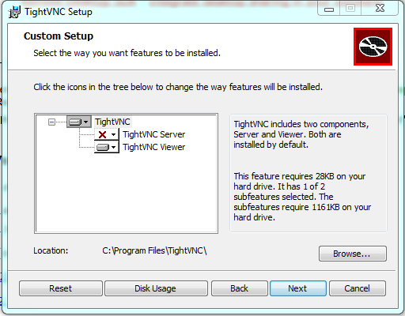

3 Now run the TightVNC viewer program (it will be in Programs:TightVNC)

This shows the the Java client connection. A similar screen is displayed for the Windows client.

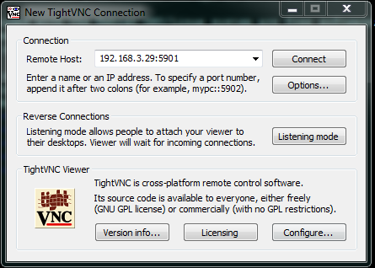

**Enter the IP Address for your Pi and make sure the default port of 5901 is used!**

4 Your Pi Desktop should now be displayed and you have full control of your Pi without a monitor, keyboard or mouse!



5 The last step is to ensure that TightVNC is restarted when the Pi restarts. In a terminal window (or putty session) complete the following steps.

Create a new file for the tightvnc service:

$ sudo nano /etc/systemd/system/tightvncserver.service

Add the following lines:

[Unit]

Description=TightVNC remote desktop server

After=sshd.service

[Service]

Type=dbus

ExecStart=/usr/bin/tightvncserver :1

User=pi

Type=forking

[Install]

WantedBy=multi-user.target

Write out the changes and save the file.

Change the file so it is owned by root

$ sudo chown root:root /etc/systemd/system/tightvncserver.service

Make the file executable by running

$ sudo chmod 755 /etc/systemd/system/tightvncserver.service

Enable startup at boot using

$ sudo systemctl enable tightvncserver.service

To test reboot your Pi and check that you can still access it remotely.

More information about installing and using TightVNC can be found at

<http://www.penguintutor.com/linux/tightvnc>

<http://www.tightvnc.com/faq.php>